Note: This document is “view only”. Please create a copy of this document and save it to your drive.

**SOP - Follow Up Ad Engagement- Systems Vault**

**PREREQUISITE**

[Teamwork PM](https://sarahnoked.teamwork.com/)

[Master: SOP- Social Media Support- Systems Vault](https://docs.google.com/document/d/16_vB_Pr2GZCtCCyKX09VqTiRhNOREd0oP2VjFtXBeLY/edit?usp=sharing)

[Sarah Noked Facebook Ad Manager](https://business.facebook.com/home/accounts?business_id=2131883050397316)

**PURPOSE**To keep up to date with comments on Facebook and Instagram ads. To invite people who interact with the ads to ‘like’ the Sarah Noked Facebook page

**POLICY**

There are daily recurring tasks in [Teamwork PM](https://sarahnoked.teamwork.com/)

Never edit an ad, never press ‘publish’ or ‘discard draft’, when you are done with engaging on the ad, just exit out of it.

**PARTY**

VIrtual Assistant

**PROPERTY**

Online Business Manager

**PROCESS**

Part 1: Access All Ads Currently Running

Part 2: Follow up with comments on the ads and take action

Part 3: Invite people who ‘liked’ the ad to ‘liked’ the Facebook Page Sarah Noked OBM

Part 4: Repeat for all ads that are running

**PROCEDURE**

**Part 1: Access All Ads Currently Running**

* 1. Click into the [Business Manager](https://business.facebook.com/home/accounts?business_id=2131883050397316) on the top left side of the screen > [Ads Manager](https://business.facebook.com/adsmanager/manage/campaigns?act=10152719819340123&business_id=2131883050397316&global_scope_id=2131883050397316&date=2020-03-07_2020-11-04%2Clifetime)

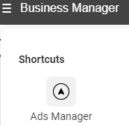

* 1. Make sure your date range is up to date (it doesn’t matter how long back you are going, but it needs to be up until today, ex. Jul 20th) 
  2. Click on the the campaigns that are currently on (they will have  marked on)
     1. Check the box of the campaign 
     2. And then click the “Ads for 1 Campaign” tab
  3. Once you are in the ads tab, see which ads are currently running (they will have  and “Active” marked on) 
  4. Hover over the ad and click Edit 

1. Access the ad with comments
   1. You should see a section of ‘Ad Preview’ 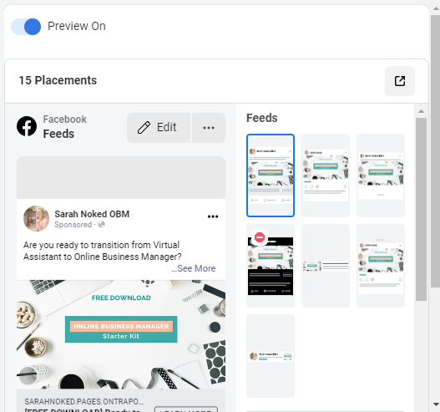
   2. Click on the arrow 
   3. Choose to See Post: Facebook Post with Comments 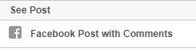

**Part 2: Follow up with comments on the ads and take action**

* 1. Review any comments on the ads
  2. If this is a negative comment, hide it
  3. If this is a mean or malicious comment, delete it and block the user
  4. If this is a positive comment that needs Sarah’s reply
     1. React to the comment (Like/Heart/other emoji)
     2. If it is a comment that you can handle, leave a reply. If it is business-specific or Sarah-specific, Message Sarah on Teamwork Chat to follow up with the comment, send her a link to the ad (the ads will pop up as new URLs for you, so just copy the URL)

**Part 3: Invite people who ‘liked’ the ad to ‘liked’ the Facebook Page Sarah Noked OBM**

* 1. Click on the people who liked the ad
  2. You will now be taken to a page where you can invite people to like the ad
  3. Scroll through and see if there are any new people to Invite to like
  4. When you’re done, close the Facebook tab > go back to the Ads Manager tab > click the back arrow on the top left of the screen to return to the screen with the other running ads 

**Part 4: Repeat for all ads that are running**Make sure to do this on all the running ads for all the running campaigns.

**Created by:**

**Date:**

**Department:** Operations & Support

**Revised:**

**Revised by:**